Homo-morphism

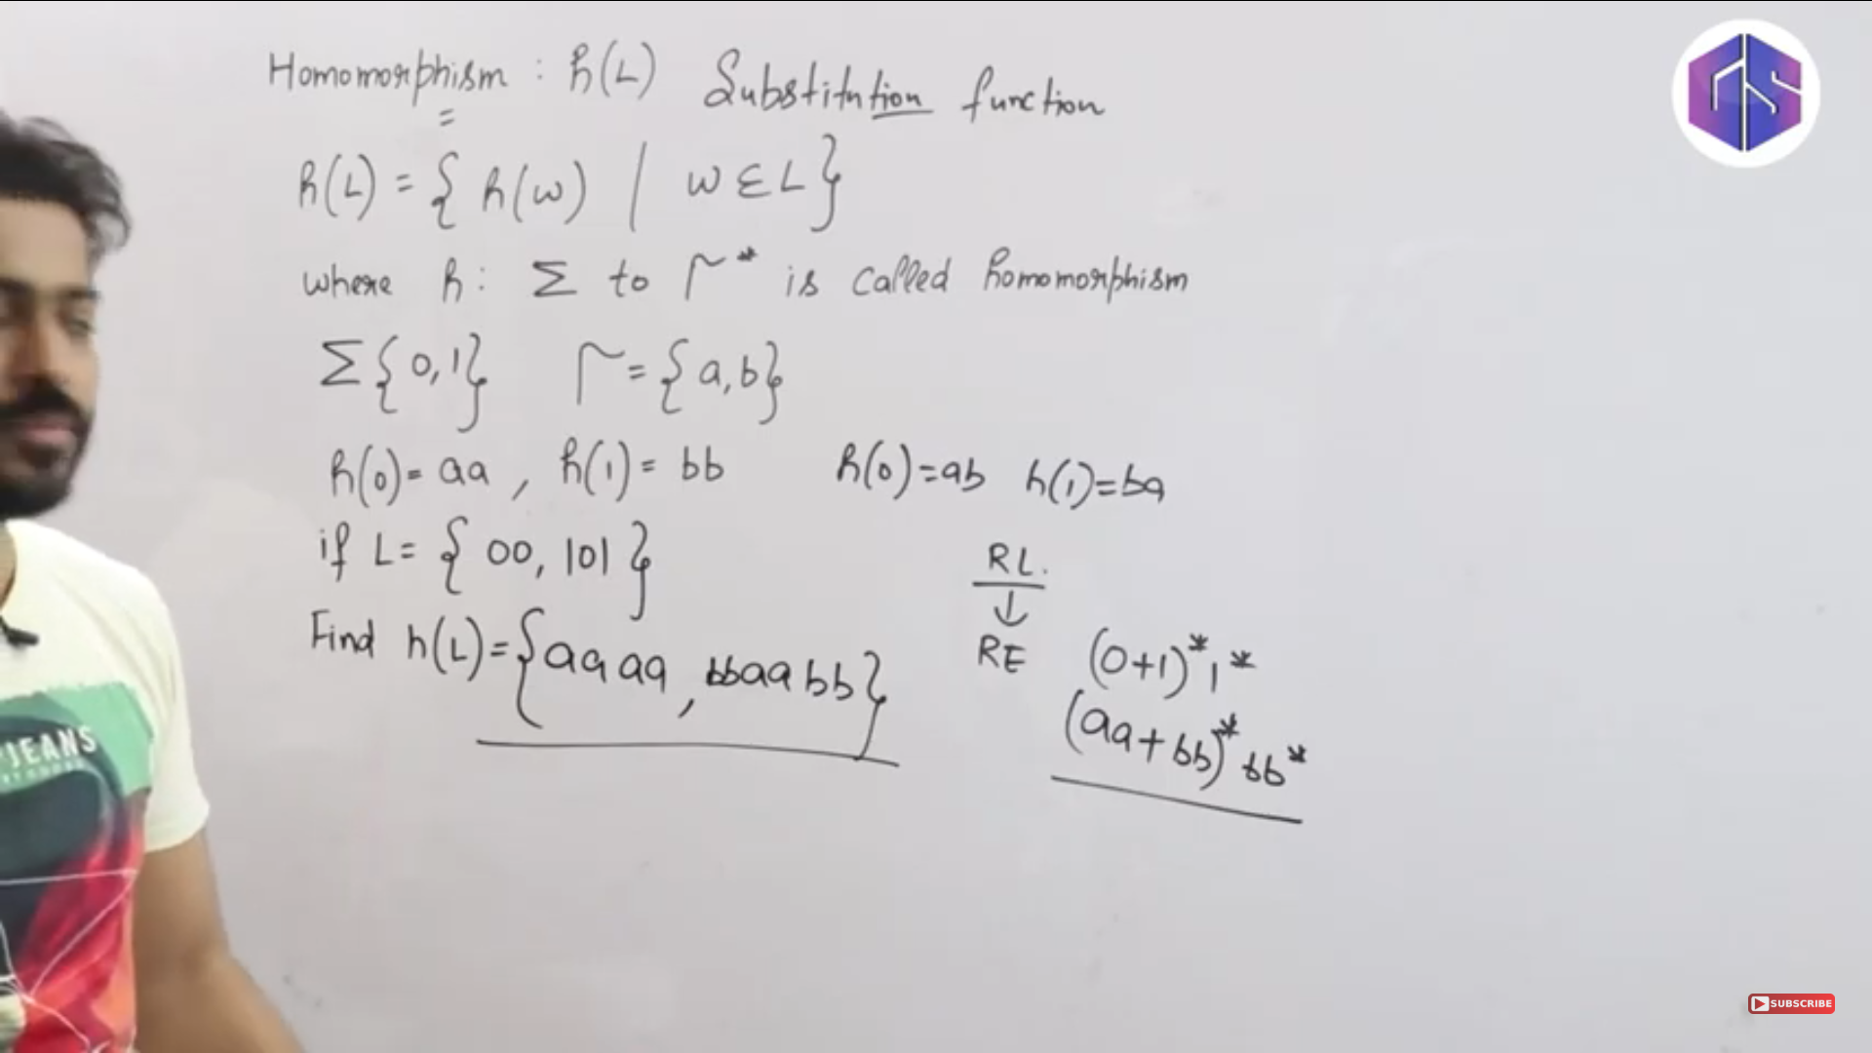

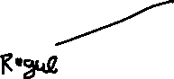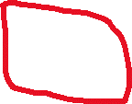

Substitute in place of the input symbols



Write the homo-morphic image of the given regular grammar

After applying homo-morphism on the regular grammar also we are getting a regular grammar. **So regular language/regular grammar is closed under HOMOMORPHISM.**

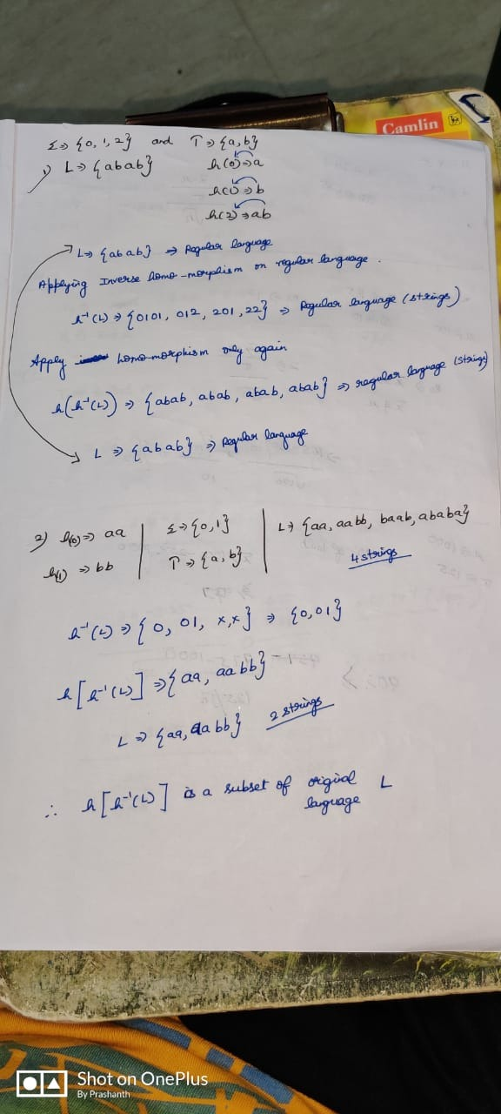

Homo-morphism and Inverse homo-morphism of a regular language 🡪 Always a regular language.